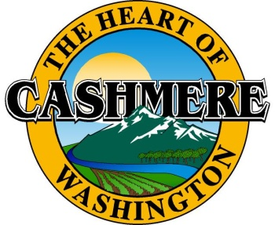

City of Cashmere

Amount Paid

Date

Receipt No.

Received by

101 Woodring Street

Cashmere, WA. 98815

Utility Reimbursement Agreement Application

|  |  |  |  |  |  |  |  |  |  |
| --- | --- | --- | --- | --- | --- | --- | --- | --- | --- |
|  | | | | | | | | Date | |
| Name of Applicant: | | | | | | | |  | |
| Mailing Address: | | | | | | | | | |
| City: | | State: | | Zip Code: | | E-Mail Address: | | | |
| Telephone No.: | | | Fax No.: | | | | Toll Free No.: | | |
| **Improvement Type (check one):** | | | | | | | | | |
| Water | Sewer | | Storm facilities | | Street Facilities | | Other | |  |

|  |  |
| --- | --- |
| **Abbreviated Legal Description:** | **Please submit the following documents: (Checklist)** |
|  | Legal description of property served,  Legal descriptions and names, address, size of parcel #’s of property owners within reimbursement area,  A copy of design drawings,  Certified statement by a licensed engineer containing itemization of the total projected cost of system,  Map of reimbursement area  Provide performance bond and Insurance |

|  |  |
| --- | --- |
| **Name of Contractor:** | |
| **Address:** | |
| License number |  |
| Bond number |  |
| Insurance Company name/number: |  |

|  |  |  |
| --- | --- | --- |
| **SIGN HERE🡺** | **Signature:** | **Date** |

### General Information:

Latecomer agreements, also referred to as recovery contracts or reimbursement agreements, allow a property owner who has installed street or utility improvements to recover a portion of the costs of those improvements from other property owners who later develop property in the vicinity and use the improvements. Two different statutes, chapter 35.72 RCW for streets, and chapter 35.91 RCW for utilities, govern these. Chapter 35.72 RCW allows a municipality to be considered as a property owner that can be reimbursed under a street latecomer agreement, but chapter 35.91 RCW does not afford that

Latecomer agreement charges are also not to be confused with connection fees, also known as facilities charges or system development charges, for utilities under chapter 35.92 RCW. These fees or charges are a property owner's equitable share of the cost of the entire utility system and not just for improvements that serve his/her property.

To provide for reimbursement, for a period not to exceed 15 years, of a portion of the costs of the project by other property owners who: 1) are determined to be within an assessment reimbursement area; 2) are determined to have a reimbursement share; 3) did not contribute to the original cost of the street project; and 4) subsequently develop their property within the 15-year period and at the time of development are not required to install similar street projects because they were already provided by the original developer.